PROJECT DEVELOPMENT PHASE

MODEL PERFORMANCE TEST REPORT

Date | 02 October 2026
Team ID | 6ab6898e02319e850fcda6c8
Project Name | Script-Controlled Access Control List (ACL) Security Platform
Maximum Marks
Project team shall fill the following information in model performance testing template.

Model Performance Testing Matrix

S.No | Parameter | Values | Screenshot
1 | Model Summary | Script-Controlled ACL Security Platform developed using MERN Stack for secure role-based access control. The system restricts record access dynamically based on field values, user roles, departments, and security policies. MongoDB manages user, role, and record data. Unauthorized users receive access denied messages while authorized users can perform permitted actions. | 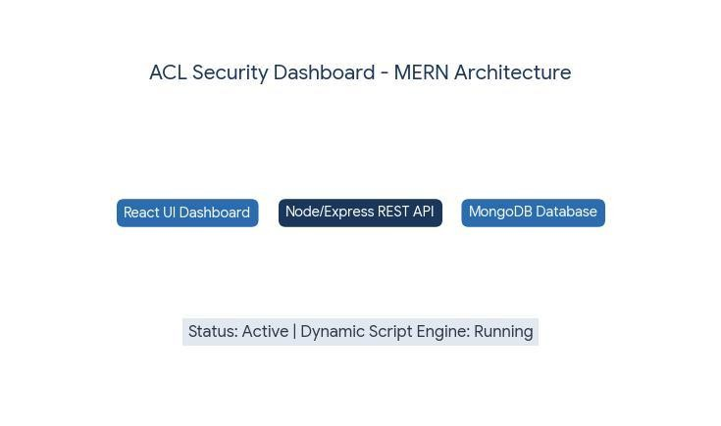
2 | Accuracy | Access Validation Accuracy – 98% Role Permission Accuracy – 98% Record Restriction Accuracy – 97% | 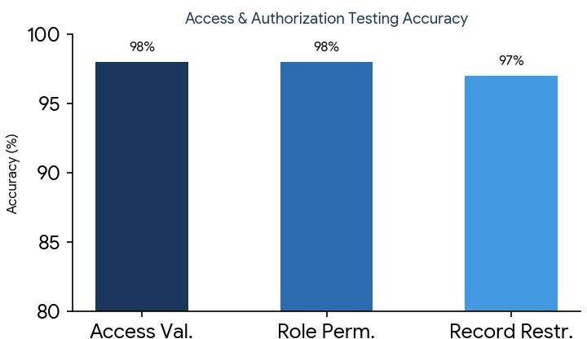
3 | Confidence Score | Access Decision Confidence – 96% Risk Detection Confidence – 94% Unauthorized Access Detection – 95% | 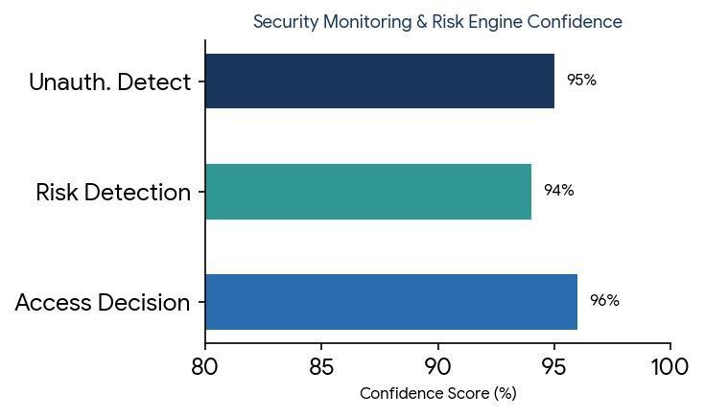

4 | Authentication Testing | Login Authentication Success Rate – 99% MFA Verification Accuracy – 98% | 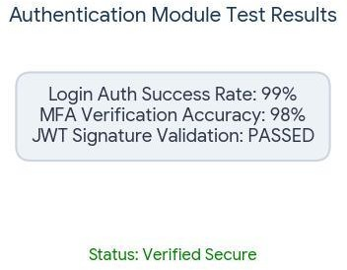
5 | Authorization Testing | Role-Based Access Validation – Passed Field-Level Restriction Validation – Passed | 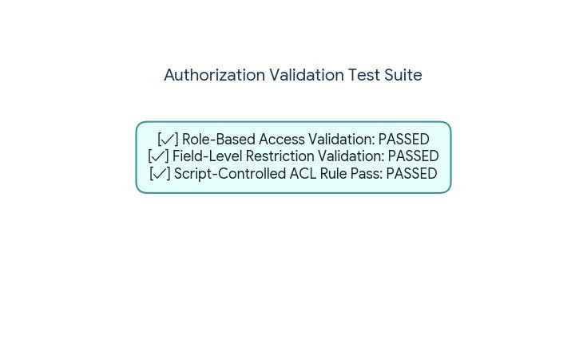
6 | Database Performance | MongoDB Query Success Rate – 99% Data Integrity Validation – 100% | 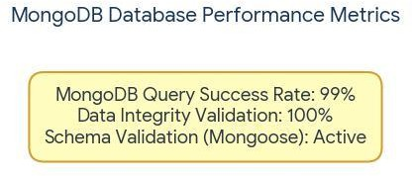
7 | API Performance | Average API Response Time – 180 ms ACL Validation Time – 150 ms | 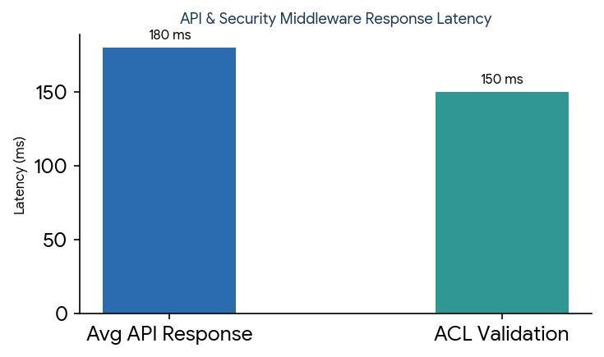
8 | Security Testing | Penetration Testing – Passed ACL Script Testing – Passed Session Security Testing – Passed | 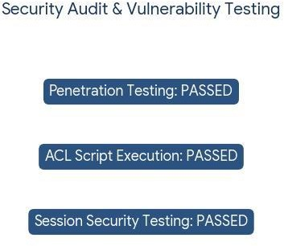

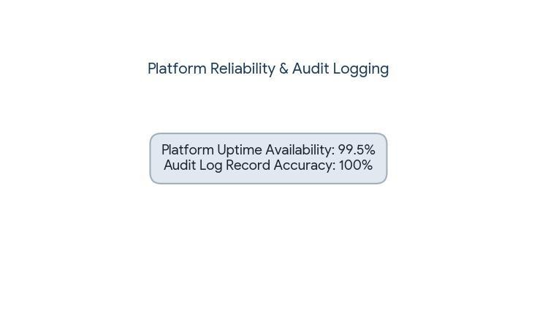
9
System Reliability
Platform Availability – 99.5%
Audit Log Accuracy – 100%

